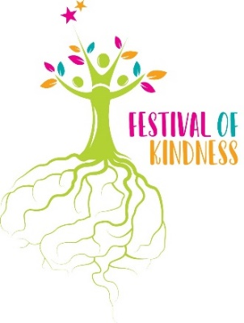**Astrea Festival of Kindness 2020**

**Pupil and Parent Engagement**

|  |  |  |
| --- | --- | --- |
| **Be kind to yourself** | **Kindness in the home** | **Kindness in the community** |
| **5 acts of kindness to myself!**  Children to write/draw 5 things that they could do over the week to show themselves some kindness ie. have a bubble bath, read a book, make up a dance, choose some music to have with breakfast to start the day, watch a movie etc. | **Take-away acts of kindness!**   |  | | --- | | **K** – Keep my bedroom tidy  **I** – I will ….  **N** – Notice…  **D** – Dry the dishes  **N** -  **E** – Empty the kitchen bin  **S** – Send a letter to granny  **S** – Sit and read to my little  brother |  |  |  |  |  |  | | --- | --- | --- | --- | --- | | Take-away tokens of kindness | | | | | | Read a bedtime story to me little sister | Give mum a hug | Empty the kitchen bin | Wash the dishes | Make mum a cup of tea |   Pupils to create a kindness poster or tear off tokens of acts they can do within the home to help others. | **Paint a pebble/stone**  Pupils to paint a stone with either a word of encouragement or picture for people to find (take a photo with) and re-hide again during their daily walk in the community. |
| **Positive message of kindness in nature**  Pupils to collect natural objects when on their daily walk to create a collage/word/  picture that brings happiness to them | **Compliment jar**  Strips of paper where all family members can write a compliment to put in the jar. These could be read daily at the dinner table. | **Postcard of thanks!**    Pupils to write a postcard of thanks to a local shop, care home, bin collection, neighbour |
| **Selfie**      Look in a mirror or perhaps use a photograph and write down 5 things that you like about yourself. | **Joke Book**    Ask everyone in the house to give you their favourite joke, ask other family members over the telephone, put them together to make a joke book. Read them all together and have a giggle. | **Tree of Appreciation**    Pupils to collect on their daily walk a cut out leaf from a polly-pocket attached to the school gate. At home they can write words of appreciation to a member of their school community ie. teacher, TA, caretaker, lunchtime supervisor, friend. These could be returned to a return polly-pocket the next day on their walk. Staff could laminate and place on a tree on the school fence for all to read as they walk past. |
| **A – Z**    Make an A – Z of things that make you feel happy! | **Superhero Kindness Diary**    Try using a camera, it could even be a phone or a tablet if you have one and take a photograph of something that made you or others happy today. Over the week build an album or make a photo screen show and share with your family. | **Positive Quote Poster**    Make a poster to put in your window. Use a positive and inspirational quote, you can make one up or you can use google to find one that you like. |

Other support for Mental Health and Wellbeing

