Midday Supervisor x 4

Atlas Academy

Recruitment Pack

Contents

- Welcome Letter – Libby Nicholas, CEO
- Welcome Letter, Helen Broad, Executive Principal
- Astrea Academy Trust
- Astrea Academy Trust Ethos
- Astrea Academy Trust Family
- Job Description
- Person Specification
- Child Safeguarding Policy
- Explanatory Notes
- How do I apply?

Welcome Letter

Dear Candidate,
Thank you for your interest in this role within the Astrea Academy Trust.
This is a hugely exciting time for our family of academies. The Trust has been recognised by the Department for Education as being well placed to raise standards and achieve excellence for pupils in a growing number of academies. We are presented with a rare opportunity to make a real difference to the lives and life chances of so many primary and secondary school children – many of whom haven’t previously received the educational opportunities they deserve.
The Trust currently has academies based across South Yorkshire and Cambridgeshire, including academies at various stages of development. As a Trust, we are clear about the importance of achieving long term sustainability for our academies. Our vision is to enable individual academies to flourish with real autonomy, whilst also ensuring a strong ethos of support and collaboration across our Academies.
Employees within Astrea belong to a community of professionals, and benefit from a wide range of networks and development opportunities across the Trust. The Trust provides a strong culture of collaboration and support, together with high expectations for staff and pupils alike.
Those we recruit can demonstrate that they share our values, are highly motivated to work with colleagues within and beyond their academy to continuously develop their skills and pursue professional excellence, and are committed to providing the highest standards of teaching for all children. If that is you then we would be delighted to receive your application.

Libby Nicholas
Chief Executive, Astrea Academy Trust

A Warm Welcome, from Helen Broad
Dear Candidate,
Thank you for your interest in the post at our Academy.
Atlas Academy is a 3-11 Academy; we sit in central Doncaster and joined Astrea Academy Trust in November 2017. We have a committed team that are dedicated to school improvement and strive for the best outcomes for all learners. The Academy is seeking to attract a talented, knowledgeable, and committed Building Supervisor. The successful candidate will have the opportunity to work in a vibrant, professional learning community that seeks excellence and be a key part of our next chapter in our journey.
Atlas Academy is on a drive to rapidly improve, we place emphasis on high aspiration and consistently excellent teaching. Our children work extremely hard. All staff are committed to providing the very best education for all children. We strive to ensure the teaching and learning at Atlas is inspirational. We have clear, shared goals to develop well-balanced individuals. Teamwork is a strong part of our ethos, with a culture of continual improvement in all that we do; we seek to continue on our journey to be the best that we can be; inspiring beyond measure.
Astrea Academies Trust is an inspirational academies network that aims to give children and young people from all backgrounds an education that will transform their lives. Membership of the Astrea Academies Trust provides enhanced CPD opportunities for staff. As part of the Astrea family, Academies retain autonomy whilst ensuring a strong ethos of support and collaboration across the Trust.
We are seeking to recruit those who share our moral purpose and are seeking to continually develop their skills to ensure excellence. I look forward to showing you around our Academy and answering any questions you may have.
Yours sincerely,
Helen Broad
Executive Principal
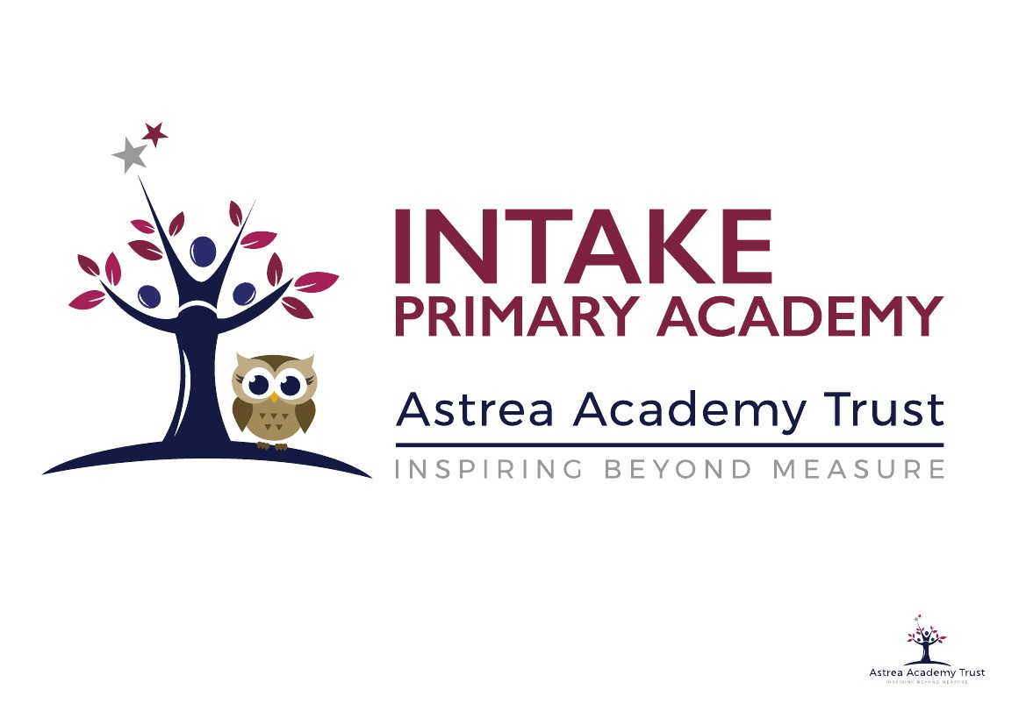

Astrea Academy Trust
We value all-round development of the individual, through arts, sports, leadership opportunities, enrichment and community. This is encapsulated in the skills, qualities and personalities we foster in our pupils.
The Astrea Academy Trust logo communicates the values collaboration, development and aspiration. The three figures are coming together in the shape of a tree, which represents growth, whilst the tallest figure reaches upwards, towards a star, which is above and beyond the highest branch of the tree.
Academies, staff and children within the Trust benefit from a strong ethos of support and collaboration across the Astrea family. Teachers within Astrea belong to a national community of professionals, and benefit from a wide range of networks and development opportunities across the Trust.
Astrea benefits from the involvement of leading educationalists, including our Professional Adviser Professor John West-Burnham, and strong links to prestigious institutions such as the Institute of Education.

All members of staff are encouraged to use the Astrea Academy Sheffield Nursery for any eligible children in their care. The Nursery and Primary prospectus can be found here; https://astreasheffield.org/nursery/

Astrea Academy Trust Ethos

The work of the Astrea Academy Trust is underpinned by five core Value Partners, which are equally applicable to pupils, staff and the work of the Trust itself.

Each pair of Value Partners is accompanied by a call for action in the form of a hashtag, which is used in verbal, digital and hard copy communications.

The Value Partners can be used as a measure of individual, Academy and Trust progress and as a guide to inform the direction of change.

Responsibility and Leadership
Individuals in the Astrea community are accountable for their own decisions and actions and are supported by strong leaders, while trailblazers are encouraged to develop skills and talents in others. The Trust has a strong commitment to developing and nurturing our own leaders. #4equity

Enjoyment and Innovation
We know that everyone learns best when they enjoy what they do and can follow their innate desire to achieve. Astrea pushes boundaries so that pioneering ideas are tried and tested so that our academies remain leaders in the advancement of teaching and learning methods. #go4it

Aspiration and Development
Every member of the Astrea community, from the youngest pupil to the oldest member of staff, is encouraged to cultivate opportunities to grow. We achieve excellence by being inspired to become the best we can be. The progress and well-being of pupils is our top priority, at the centre of every decision. #Astreastars

Collaboration and Inclusion
Astrea honours and applauds the differences that make us unique whilst actively seeking and celebrating the common ground that binds us together as a strong community. We work together in a productive environment where dynamic ideas are shared in partnership, so that every member of the community may thrive #all4one

Honesty and Integrity
We are honest and open. Astrea decisions and responses are grounded in time-honoured moral principles that remain constant in the face of challenges and change #4good
You can learn more about the Values, and hear from staff and pupils across Astrea Academies, at our website: https://astreaacademytrust.org/

Astrea Academy Trust Family
Academies currently within Astrea Academy Trust:
Primary | Website
- Atlas Academy, Doncaster | http://www.astreaatlas.org/
- Byron Wood Academy, Sheffield | https://astreabyronwood.org/
- Carrfield Primary Academy, Rotherham | https://www.astreacarrfield.org/
- Castle Academy, Doncaster | https://www.astreacastle.org/
- Highgate Primary Academy, Doncaster | https://www.astreadenabymain.org/
- Edenthorpe Hall Academy, Doncaster | https://astreaedenthorpehall.org/
- Gooseacre Primary Academy, Rotherham | https://www.astreagooseacre.org/
- Greengate Lane Academy, Sheffield | https://www.astreagreengatelane.org/
- Hartley Brook Primary Academy, Sheffield | https://www.astreahartleybrook.org/
- Hatfield Primary Academy, Sheffield | https://www.astreahatfield.org/
- Hexthorpe Primary Academy, Doncaster | https://www.astreahexthorpe.org/
- Highgate Primary Academy, Rotherham | https://www.astreahighgate.org/
- Hillside Academy, Doncaster | https://astreahillside.org/
- Intake Primary Academy, Doncaster | https://www.astreaintake.org/
- Kingfisher Primary Academy, Doncaster | https://www.astrea-kingfisher.org/
- Lower Meadow Primary Academy, Sheffield | https://www.astrealowermeadow.org/
- Highgate Primary Academy, Rotherham | https://www.astreathehill.org/
- Waverley Primary Academy, Doncaster | https://www.astreawaverley.org/
Secondary
- Astrea Academy Woodfields, Doncaster | http://astreawoodfields.uk/
- Cottenham Village College, Cambridgeshire | https://www.astreacottenham.org/
- Ernulf Academy, Cambridgeshire | http://www.ernulf.cambs.sch.uk/
- Longsands Academy, Cambridgeshire | http://www.longsands.cambs.sch.uk/
- Netherwood Academy, Barnsley | https://astreanetherwood.org/
- St Ivo School, Cambridgeshire | http://stivoschool.org/
- The Dearne Academy, Rotherham | https://thedearnealc.org/
Special School
- The Centre School, Cambridgeshire | https://www.astreacentreschool.org/
All-through
- Astrea Academy Sheffield, Sheffield | https://astreasheffield.org/

Job Description
Position: Mid day Supervisor x 4
Salary: Grade 3 scale point 1 £2460 pa
Hours of work: 6.25 hours per week
Contract Type: Permanent
Reporting to: Executive Principal
Location of this position: Atlas Academy, Doncaster
Purpose of this role:

To assist with the supervision of pupils during times when normal teaching activities are not undertaken. This job description is to be performed in accordance with the provisions of the current NJC Pay and Conditions Document. The performance of these duties is under the reasonable direction of the Executive Principle.
The main employment duties attaching to this post are as follows:
- To support the welfare, health and safety of pupils at designated times.

- To promote and foster good relationships between pupils through the engagement in play and games activities

- To lead and encourage pupils to take part in activities and games appropriate to their age and abilities

- To challenge inappropriate behaviour and to provide pupils with boundaries of acceptable behaviour

- To identify any causes of concern displayed by pupils and to report these to a class teacher where appropriate

- To arrange for first aid to be administered

- To oversee the smooth running and cleanliness of dining areas, e.g. clean up spillages and ensuring eating areas are hygienic.

In addition to the above the general areas of responsibilities you will:

Be able to administer basic first aid and follow regular updating by attending a first aid course.

These duties and responsibilities should not be regarded as exhaustive or exclusive. The job description and allocation of particular responsibilities will be reviewed on a yearly basis and may be amended by the Executive Principle at any time after consultation.

Visits to school are welcome, please contact Catherine Mitchell on 01302 363612 to arrange a visit.

Closing date for applicants is Friday 25th October 2019
Interviews will be held on Monday 4th November 2019

Person Specification
This part will allow you to understand who we are looking for within this role and the skills knowledge or experience that we would expect.

ATTRIBUTES/REQUIREMENTS | ESSENTIAL | DESIRABLE | HOW IDENTIFIED
EDUCATION, QUALIFICATIONS  AND VOCATIONAL TRAINING | Willingness and ability to obtain and/or enhance qualifications and training for development in the post. | First Aid Certificate | Application Form  Examination of Certificates  Interview
RELEVANT EXPERIENCE | Caring for children/young people. | Engaging in children’s activities in a formal setting.  Current school environment. | Application Form  Interview  References
KNOWLEDGE AND SKILLS | Good oral communication  Health and Safety Issues  First Aid | Education Service  Child Protection Procedures | Application Form  Interview  References
PERSONAL CHARACTERISTICS | Ability to relate well to children.  A pleasant and sympathetic manner.  Ability to work as part of a team. | Flexible approach.  Patience.  Caring. | Interview  References
PHYSICAL ATTRIBUTES | As assessed and advised by Occupational Health |  | Medical Questionnaire  Medical examination if required
ADDITIONAL FACTORS | 2 positive references including positive recommendation from current/ latest employer |  | Interview
CONTRA-INDICATORS | A satisfactory enhanced DBS record check.

Child Safeguarding Policy

The Trust is committed to Safeguarding and Promoting the Welfare of all its pupils. Each student’s welfare is of paramount importance. We recognise that some children may be especially vulnerable to abuse e.g. those with Special Educational Needs, those living in adverse circumstances.

We recognise that children who are abused or neglected may find it difficult to develop a sense of self-worth and to view the world in a positive way. Whilst at the Academies, their behaviour may be challenging. We will always take a considered and sensitive approach in order that we can support all our pupils.

The Trust’s Child Safeguarding Policy applies to all adults, including volunteers, working in or on behalf of the Trust.

Everyone in the education service shares an objective to help keep children and young people safe by contributing to:
- Providing a safe environment for children and young people to learn in education settings; and
- Identifying children and young people who are suffering or likely to suffer significant harm, and taking appropriate action with the aim of making sure they are kept safe both at home and in the education setting’

Keeping Children Safe in Education 2016

The Trust pays full regard to ‘Keeping Children Safe in Education’ guidance 2016. We ensure that all appropriate measures are applied in relation to everyone who works for the Trust who is likely to be perceived by the children as a safe and trustworthy adult including e.g. volunteers and staff employed by contractors. Safer recruitment practice includes scrutinising applicants, verifying identity and academic or vocational qualifications, obtaining professional and character references, checking previous employment history and ensuring that a candidate has the health and physical capacity for the job. It also includes undertaking interviews and an Enhanced DBS check.
Please visit https://astreaacademytrust.org/about-us/statutory-documents/ for the full policy as well as other Astrea Academy Trust policies.

Explanatory Notes

Applications will only be accepted from candidates completing the Trust’s Application Form. Please complete ALL sections of the Application Form which are relevant to you as clearly and fully as possible. CVs will not be accepted in place of a completed Application Form.

Safeguarding Children and Young People

We are committed to safeguarding and promoting the welfare of children and young people. We expect all staff to share this commitment and to undergo appropriate checks, including an enhanced check.

- Candidates should be aware that all posts in Astrea Academy Trust involve some degree of responsibility for safeguarding children and young people, although the extent of that responsibility will vary depending on the nature of the post. Please see the job description enclosed in this Application Pack for further details.
- Accordingly, this post is exempt from the Rehabilitation of Offenders Act 1974 and therefore all convictions, cautions and bind-overs, including those regarded as “spent” must be declared.
- If you are currently working with children, on either a paid or voluntary basis, your current employer will be asked about disciplinary offence, including those related to children or young people (whether disciplinary sanction is current or time-expired), and whether you have been the subject of any child protection allegations or concerns and if so the outcome of any investigation or disciplinary proceedings. If you are not currently working with children, but have done in the past, that previous employer will be asked about these issues.
- Where neither your current or previous employment has involved working with children, your current employer will be asked about your suitability to work with children, although it may be answered not applicable where it is appropriate; if your duties have not brought you into contact with children or young people for instance.

Interview Process

After the closing date, short listing will be conducted by a Panel. You will be selected for interview entirely on the contents of your application form, so please read the Job Description and Person Specification carefully before you complete your form.

All candidates invited to interview must bring the following documents:

- Documentary evidence of right to work in the UK
- Documentary evidence of identity that will satisfy DBS requirements
- Documentary proof of current name and address
- Where appropriate any documentation evidencing change of name
- Documents confirming any educational or professional qualifications that are necessary or relevant for the post

Please note that originals of the above are necessary, photocopies or certified copies are not sufficient.

We will seek references on shortlisted candidates for Trust based positions and may approach previous employers for information to verify experience or qualifications before interview. Any relevant issues arising from references will be taken up at interview.

In addition to candidate’s ability to perform the duties of the post, the interview will also explore issues relating to safeguarding and promoting the welfare of children, including:

- Motivation to work with children and young people
- Ability to form and maintain appropriate relationships and personal boundaries with children and young people
- Emotional resilience in working with challenging behaviours
- Attitudes to use of authority and maintaining discipline

Conditional Offer: Pre-Employment Checks

Any offer to a successful candidate will be conditional upon:

- Verification of right to work in the UK
- Receipt of at least two satisfactory references (if these have not already been received)
- Verification of identity checks and qualifications
- Satisfactory Enhanced DBS Check
- Verification of professional status such as QTS Status, NPQH (where required)
- Satisfactory completion of a Health Assessment
- Satisfactory completion of the probationary period (where relevant)
- Where the successful candidate has worked, or been resident overseas in the previous five years, such checks and confirmations as may be required in accordance with statutory guidance

How can I Apply?
This is an exciting and very rewarding role and we look forward to receiving your application.

Please complete and send the Application Form and Equal Opportunities Monitoring Form which are available together with this document to the below contact;

Name: Catherine Mitchell
Position: Business Manager
Contact: 01302 363612 or email Catherine.Mitchell@astreaatlas.org

The Application Process

The candidates selected for interview will be informed after shortlisting and full details of the interview programme will be provided. If you do not hear from us within 14 days of the closing date of this position, unfortunately you have been unsuccessful on this occasion.
The information supplied in your application, as well as any supporting documents provided at the application or interview stage, will be used as part of the Astrea Academy Trusts Recruitment and Selection Process. All information is stored securely and all data submitted by unsuccessful candidates will be destroyed responsibly after 6 months from the date of interview.
Astrea Academy Trust pays full regard to ‘Keeping Children Safe in Education’ guidance 2016. We ensure that all appropriate measures are applied in relation to everyone who works for the Trust. Safer recruitment practice includes scrutinising applicants, verifying identity and academic or vocational qualifications, obtaining professional and character references, checking previous employment history and ensuring that a candidate has the health and physical capacity for the job. It also includes undertaking interviews and an Enhanced DBS check. Please visit https://astreaacademytrust.org/about-us/statutory-documents/ for the full policy. The information supplied in your application, as well as any supporting documents provided at the application or interview stage, will be used as part of the Astrea Academy Trusts Recruitment and Selection Process. All information is stored securely and all data submitted by unsuccessful candidates will be destroyed responsibly after 6 months from the date of interview.

